**Znovu děkuji všem, kteří si dají práci a posílají mi úkoly. Jste super, díky. ☺**

Tady je text a správné odpovědi z minulého týdne:

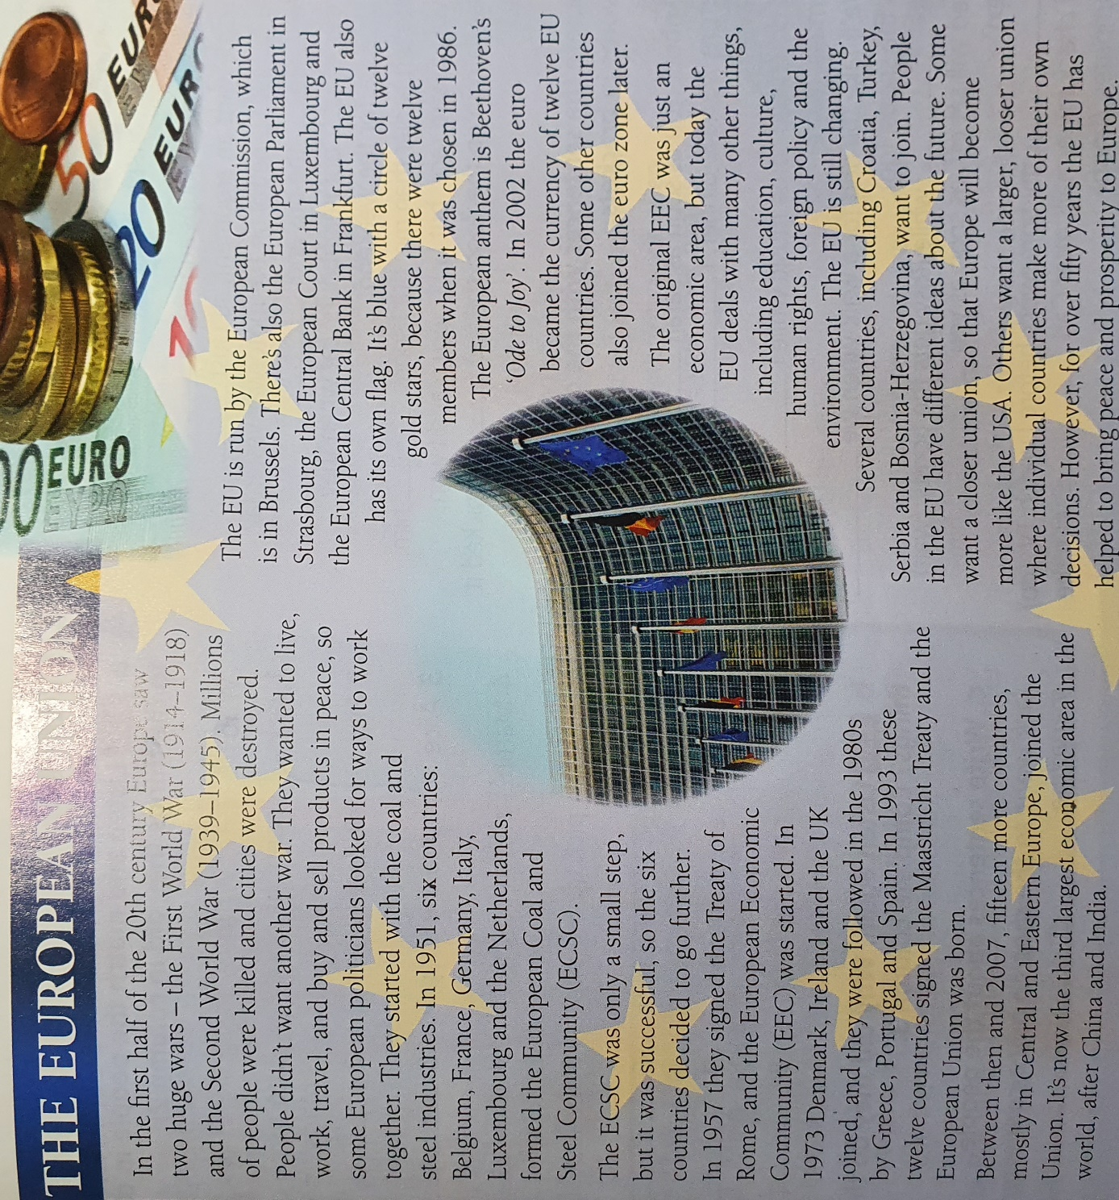

**Answers:**

1. European Coal and Steel Community.
2. Belgium, France, Germany, Italy, Luxembourg and Netherlands.
3. People didn’t want another war.
4. 1973
5. No, China and India are bigger.
6. Brussels, Luxembourg, Germany and France.
7. Because there were 12 members when the flag was chosen.

Správné řešení cvičení, zkontrolujte a opravte si chyby.



Pro tento týden trochu jiný poslech. V nahrávce jsem napsala, jak je možné posílat odpovědi, tak prosím s chutí do toho.

The Story of McDonald’s

● Listen and complete the paragraph.

**POSLECH**



There are many restaurants in the world, but probably the most famous is McDonald’s. McDonald’s 1_______ more than 34,000 restaurants around the world in 119 countries, and they2 _______ about 68 million customers every day. The story of McDonald’s 3_______ in 1940 when two brothers, Richard and Maurice (‘Mac’) McDonald 4_______ a new restaurant called ‘McDonald’s Famous Barbeque’. It 5_______ a successful business, but the brothers 6_______ to 7_______ more food and 8_______ more money, so in 1948 they 9_______ some changes. For example, they 10_______ a new way to 11_______ and 12_______ food faster – and McDonald’s 13_______ one of the first fast food restaurants in the world. In addition, they 14_______ the menu more simple: hamburgers, cheeseburgers, sodas, and milkshakes. There 15_______ no longer any waitresses to 16_______ food, so customers 17_______ food by themselves at a counter. In 1954, a man called Ray Kroc 18_______ the company and later 19_______ it for 2.7 million dollars. The company 20_______ now worth many billions of dollars. There 21_______ a McDonald’s museum that 22_______ located in San Bernardino, California where the first McDonald’s 23_______ built. It’s open daily from 10:00 am to 5:00 pm.

I toto cvičení se vztahuje k předchozímu poslechu

1. McDONALD’S LISTENING COMPREHENSION

1. The article is about hamburgers.

(a) TRUE (b) FALSE (c) It doesn’t say.

2. How many McDonald’s restaurants are there around the world?

(a) 34,000 (b) 119 (c) 68 million

3. When did McDonald’s become a ‘fast food restaurant’?

(a) 1954 (b) 1940 (c) 1948

4. Why did Richard and Maurice want to cook and serve food faster?

(a) They liked making changes. (b) It was a successful business. (c) They wanted to make more money.

5. There were fewer kinds of food on the McDonald’s restaurant menu in 1948.

(a) TRUE (b) FALSE (c) It doesn’t say.

6. There is a McDonald’s restaurant in California called ‘San Bernardino’.

(a) TRUE (b) FALSE

7. When can people visit a McDonald’s museum?

(a) They can’t because it closed in 1954. (b) only in the morning (c) every day

Procvičování:

<https://www.perfect-english-grammar.com/past-simple-present-perfect-1.html>